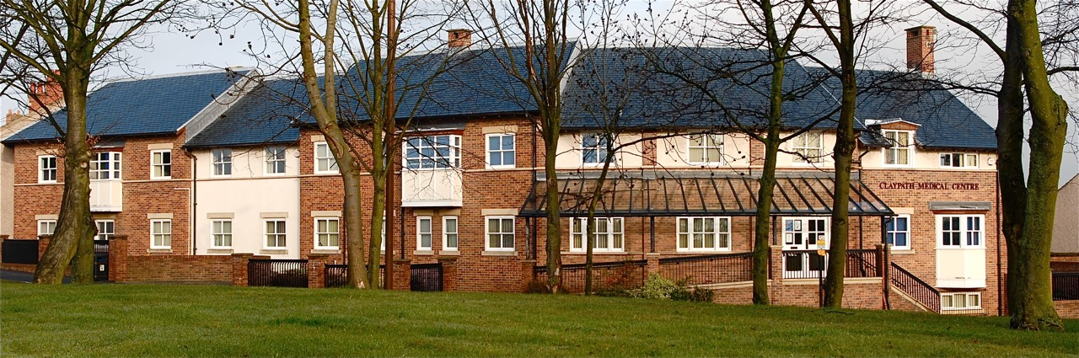

**Claypath and University Medical Group**

**DURHAM**

**Practice Manager/General Manager**   
**(Full-time)**

**Salary: Depending on experience**

We are a large forward-thinking general practice and single-practice Primary Care Network which values innovation, prioritises patient care, and champions development. Due to retirement of the current postholder, we are seeking an experienced manager to ensure the effective running of operations across our two sites whilst driving growth and sustainability in line with changing NHS policy and development.

Primary care offers meaningful, stable opportunities for those looking to apply their skills in a new setting. Even if you haven't worked in general practice before, experience in NHS operations, leadership, or system working could make you a great fit for this pivotal role!

You will need to have a strong track record of management experience in a healthcare, or similarly complex environment, a history of implementing effective systems and managing finances, familiarity with governance, along with excellent interpersonal and team skills to oversee the management of our multi-disciplinary workforce of over seventy personnel. In addition, strong business, organisational, and IT skills will be essential in managing practice/ PCN finances and ensuring compliance with General Medical Services (GMS) and Care Quality Commission (CQC) regulations.

Main duties of the job:  
  
The successful candidate will:

* work closely with GP Partners to oversee the delivery of outstanding care to patients whilst supporting and leading practice/PCN staff;
* oversee the financial, administrative, human resources, facilities management, and business functions of the practice/PCN with the support of a strong senior management team.

Overview of the organisation:  
  
The Claypath and University Medical Group is a well organised, successful, and forward-thinking GMS training practice which operates as a single practice Primary Care Network. The practice has a list size of over 33,500 patients, half of whom are students and staff from the University of Durham. Services delivered by the Claypath and University PCN include Clinical Pharmacy, Podiatry, First Contact Physiotherapy, Social Prescribing, Mental Health, Care Coordination, COVID Vaccination Clinics, Minor Surgery Clinics, Non-Scalpel Vasectomy Surgery as well as a Nurse Associate.

For informal enquiries please contact Tracy Watson (Deputy Manager) on Tel: (0191) 374 6888 or [claypath.a83011@nhs.net](mailto:claypath.a83011@nhs.net)

Applications to be submitted via on-line application form on NHS Jobs website <https://www.jobs.nhs.uk/>

Closing date for applications: Friday, 25th April, 2025

*[Interviews to held on: Friday, 16th May, 2025 (afternoon)]*